Day – 4

The yaml file is displayed in the server port using the command

system@kowshika:~$ minikube service nginx-login --url

http://127.0.0.1:39195

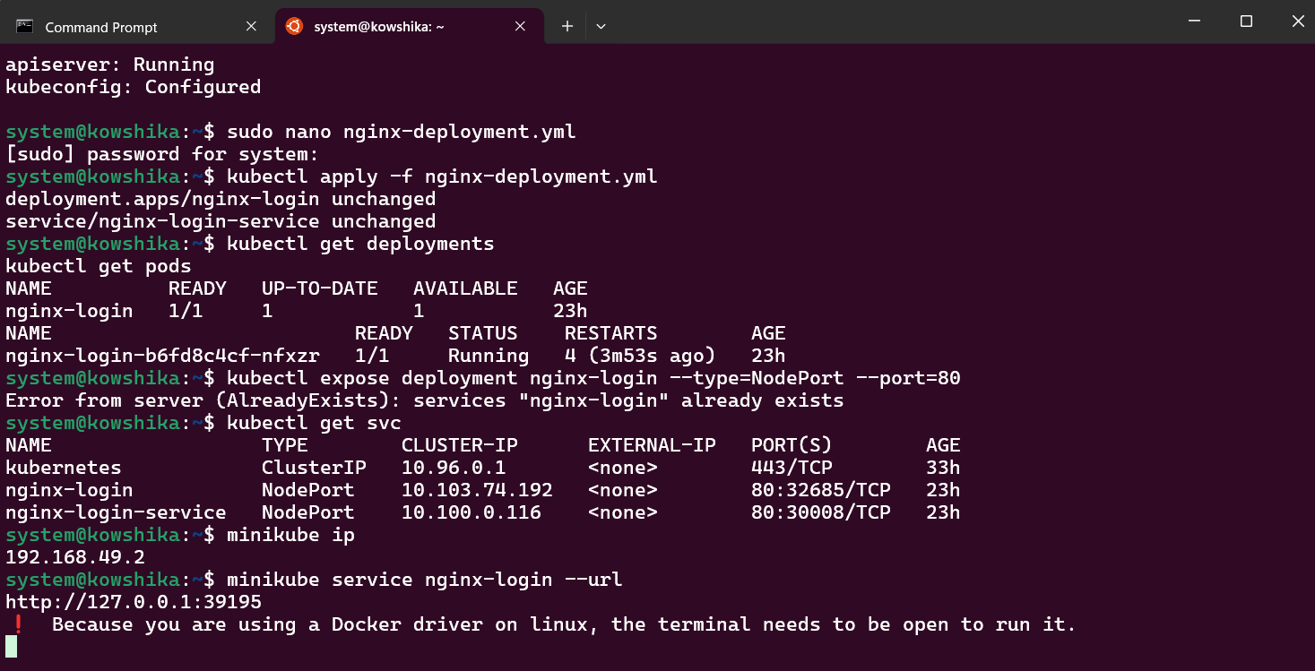

Output :

